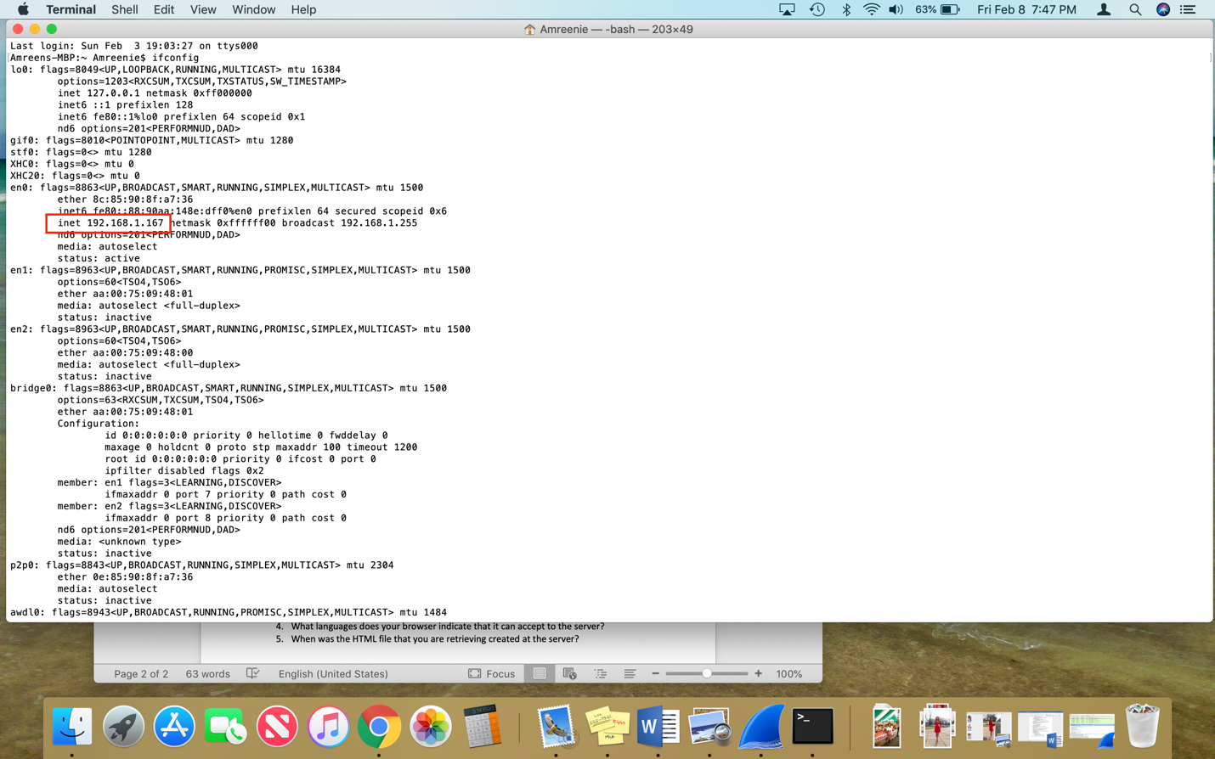

1. 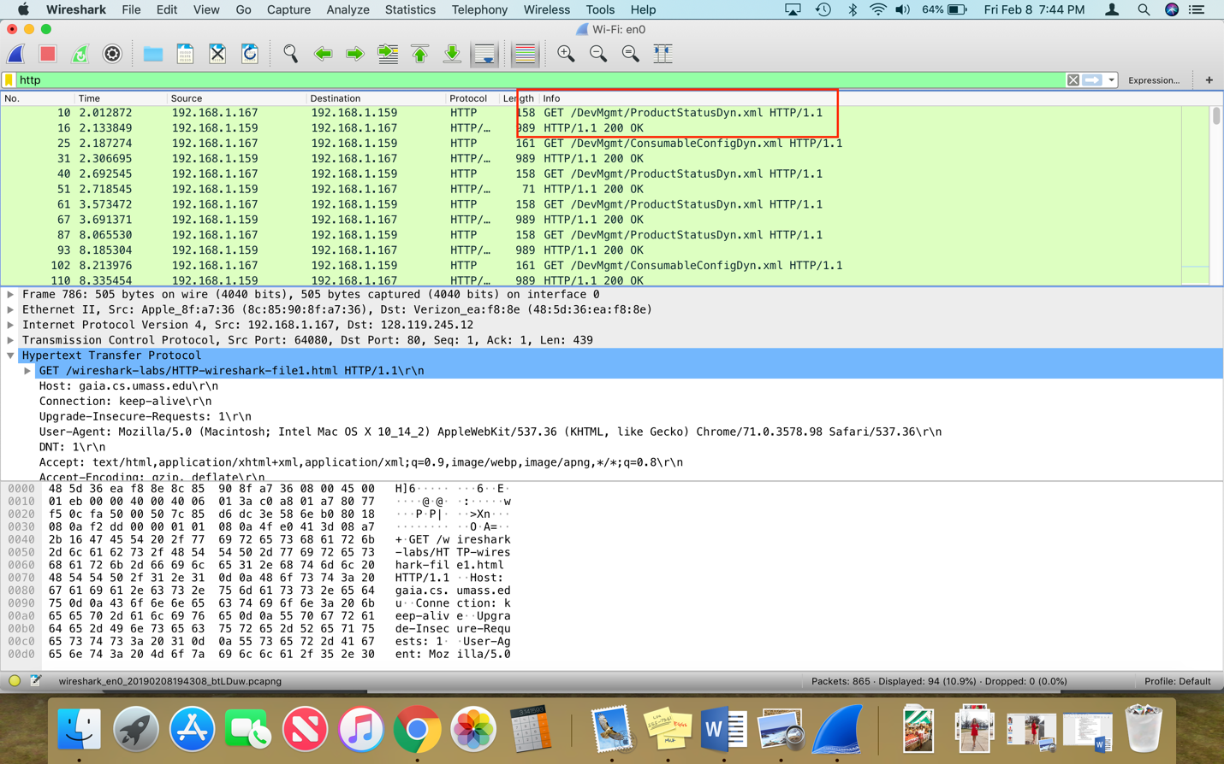Is your browser running HTTP version 1.0 or 1.1? 1.1
2. When was the HTML file that you are retrieving last modified at the server? – Friday, February 8th

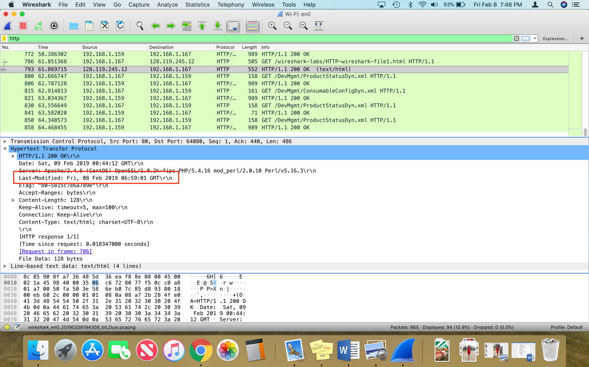

1. 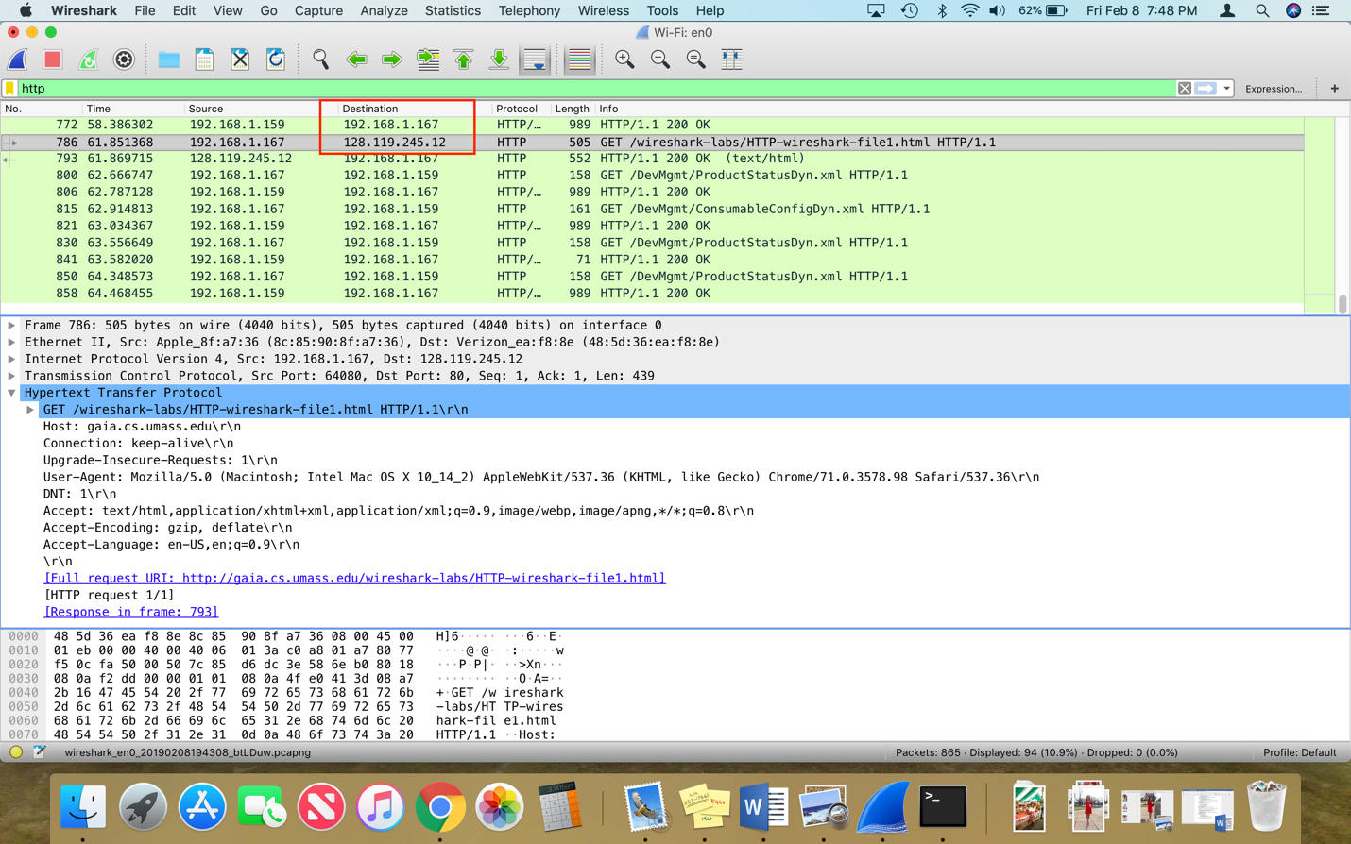What is the IP address of the gaia.cs.umass.edu server? 128.119.245.12
2. What languages does your browser indicate that it can accept to the server?

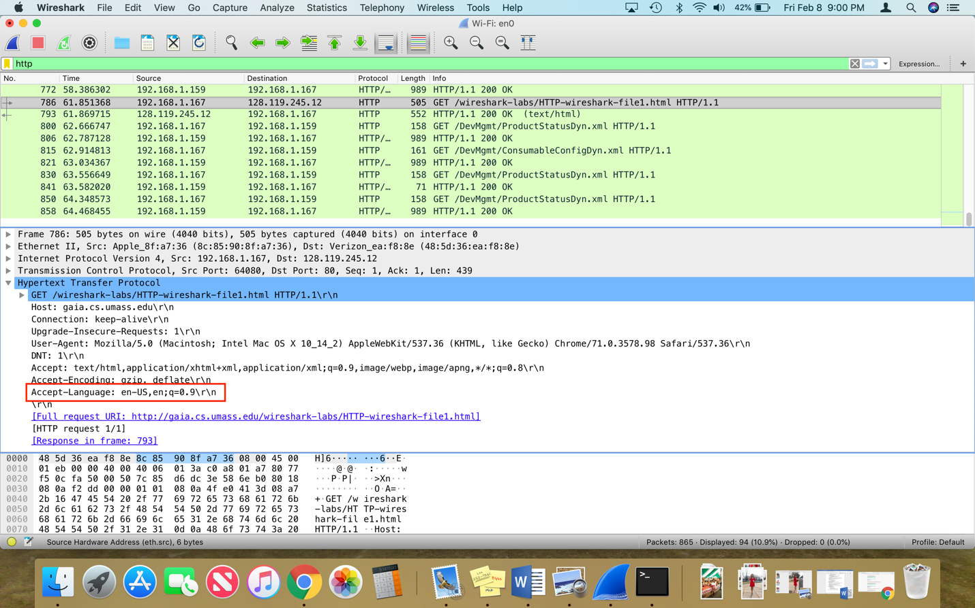It can accept English.

1. When was the HTML file that you are retrieving created at the server?

No creation date if there is a last modified date.

